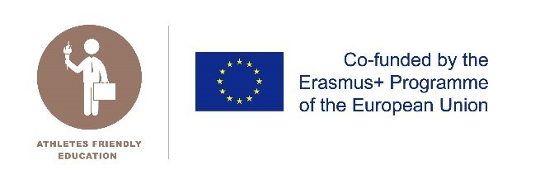  Certificate for Educational Institutions supporting  the Dual Careers of Athletes  addressee  Candidates for the members of the National Expert Group | PLACE, DATE  [Lisbon, Portugal, 03/12/2021]
CONFLICT OF INTEREST DECLARATION
I, ………………………………………………….. [Full name], declare that as a candidate for membership of the Expert Group for the Athletes Friendly Education certificate (AFE):

- I declare that I am fully aware of the rules related to impartiality as included in the ‘Criteria for members of the Expert Group’.

- I declare that I will notify the organisation immediately of any possible conflict of interest that may arise at any part of the process.

- I declare that I have completed the list below with all the positions and assignments, which are relevant for the work of the Expert Group.

List of positions within educational institutes (e.g. Board member, advisor…) in the last ten years:
[To be completed]

List of assignments (e.g. teaching assignment) related to educational institutes in the last ten years:
[To be completed]
[To be completed]
Any other possible conflict of interest in relation to education institutes:

Signed by …………………………………………….. [Full name] on ………………………………. [Date].

